**Biterm Topic Models are especially usefull if you want to find topics in collections of short texts**. Short texts are typically a twitter message, a short answer on a survey, the title of an email, search questions, … . For these types of short texts traditional topic models like Latent Dirichlet Allocation are less suited as most information is available in short word combinations. The R package BTM finds topics in such short texts by **explicitely modelling word-word co-occurrences (biterms) in a short window**.

The update which was pushed to CRAN a few weeks ago now allows to explicitely provide a set of biterms to cluster upon. Let us show an example on clustering a subset of R package descriptions on CRAN. The resulting cluster visualisation looks like this.

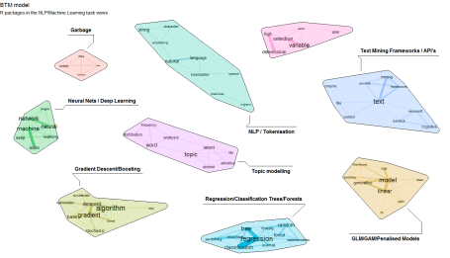

If you want to reproduce this, the following snippets show how to do this. Steps are as follows

**1. Get some data of R packages and their description in plain text**

## Get list of packages in the NLP/Machine Learning Task Views  
library(ctv)  
pkgs <- available.views()  
names(pkgs) <- sapply(pkgs, FUN=function(x) x$name)  
pkgs <- c(pkgs$NaturalLanguageProcessing$packagelist$name, pkgs$MachineLearning$packagelist$name)  
  
## Get package descriptions of these packages  
library(tools)  
x <- CRAN_package_db()  
x <- x[, c("Package", "Title", "Description")]  
x$doc_id <- x$Package  
x$text   <- tolower(paste(x$Title, x$Description, sep = "\n"))  
x$text   <- gsub("'", "", x$text)  
x$text   <- gsub("<.+>", "", x$text)  
x <- subset(x, Package %in% pkgs)

**2. Use the udpipe R package to perform Parts of Speech tagging on the package title and descriptions and use udpipe as well for extracting cooccurrences of nouns, adjectives and verbs within 3 words distance.**

library(udpipe)  
library(data.table)  
library(stopwords)  
anno <- udpipe(x, "english", trace = 10)  
biterms <- as.data.table(anno)  
biterms <- biterms[, cooccurrence(x = lemma,  
                                  relevant = upos %in% c("NOUN", "ADJ", "VERB") &   
 nchar(lemma) > 2 & !lemma %in% stopwords("en"),  
                                  skipgram = 3),  
                   by = list(doc_id)]

**3. Build the biterm topic model with 9 topics and provide the set of biterms to cluster upon**

library(BTM)  
set.seed(123456)  
traindata <- subset(anno, upos %in% c("NOUN", "ADJ", "VERB") & !lemma %in% stopwords("en") & nchar(lemma) > 2)  
traindata <- traindata[, c("doc_id", "lemma")]  
model     <- BTM(traindata, biterms = biterms, k = 9, iter = 2000, background = TRUE, trace = 100)

**4. Visualise the biterm topic clusters using the textplot. This creates the plot show above.**

library(textplot)  
library(ggraph)  
plot(model, top_n = 10,  
     title = "BTM model", subtitle = "R packages in the NLP/Machine Learning task views",  
     labels = c("Garbage", "Neural Nets / Deep Learning", "Topic modelling",   
 "Regression/Classification Trees/Forests", "Gradient Descent/Boosting",   
 "GLM/GAM/Penalised Models", "NLP / Tokenisation",  
                "Text Mining Frameworks / API's", "Variable Selection in High Dimensions"))

Enjoy!